**SAP Implementation Project**

**At**

**Government of Andhra Pradesh**

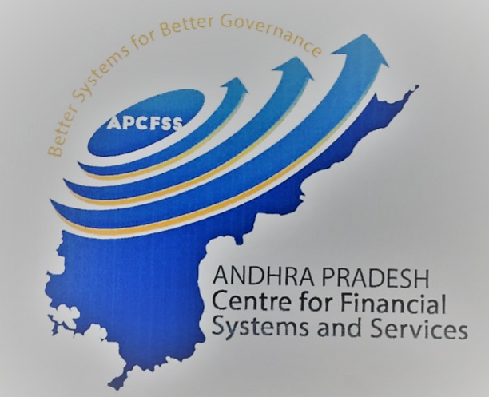

**Project CFMS**

**(Comprehensive Financial Management System)**

**Technical Design Document**

**CHALLAN SUMMARY REPORT**

Document Version :1.0

Document Release Date : 04th October, 201819.08.03 13:02

**Only for internal use**

Table of Content

1. Introduction 3

1.1 Purpose of this document3

1.2 Scope of this document3

2. Document Identification 3

3. Document History 4

4. Process Description 5

5. Reporting Scope 5

6. Functionality Requirements 5

7. TECHNICAL REQUIREMENTS - REPORTS 6

7.1 WebI Basic Overview: Annexure for Challan Summary Report6

8. TECHNICAL REQUIREMENTS - REPORTS 7

8.1 Objects, Variable and Report Controls used.7

8.2 Challan Summary-Department Wise Report Level Calculations and Formulas used9

8.3 Challan Summary-District Wise Report Level Calculations and Formulas used.9

8.4 Challan Summary of Reconciled Report Level10

8.5 Challan Summary of Non-Reconciled Report Level10

8.6 Challan Summary of In Transit Report Level10

8.7 Challan Details of In Reconciled Report Level10

8.8 Challan Details of In Transit Report Level11

8.9 Challan Status Display Report Level11

Aperndix A – 16

Appendix B – 16

# Introduction

## Purpose of this document

The purpose of this document is to describe the Technical Design CHALLAN SUMMARY DEPARTMENT & DISTRICT WISE REPORT at CFMS ( Comprehensive Finance Management System ) for Department of Finance, Govt. of Andhra Pradesh.

## Scope of this document

This document contains the technical description and design of CHALLAN SUMMARY DEPARTMENT & DISTRICT WISE REPORT.

# Document Identification

|  |  |  |
| --- | --- | --- |
| Document details | | |
| Project Name | Module | Business Scenario - |
| GoAP | Business Objects | Receipts |
| Module Lead – GoAP | Module Lead – SAP/Partner | Process Owner |
|  | Manoj Dhir |  |
| BBP Number | BBP Name |  |
|  | BO Reports |  |

# Document History

|  |  |  |  |
| --- | --- | --- | --- |
| **Authors & Participants** | | | |
| **Role** | | **Names** | |
| Core Team Member | |  |  |
| Consultant | | Nageswara Rao Adabala |  |
| Business Process Owner / FICO Lead | |  |  |
| Workshop Participants | |  |  |
| **Revision History** | | | |
| **Date** | **Document Version** | **Document Revision Description** | **Author** |
| 4/10/2018 | 1.0 | Draft for Internal Technical review | Satish Jayasuriyan |
| **Reviewed and Approved By** | | | |
| **Name** | **Title** | **Date** | **Approved** |
|  |  |  |  |

# Process Description

**4.1 Business Process: Challan Summary – Department Wise**

This report “Challan Summary – Department Wise” gives the information on challan details of Department, Reconciled and Non-Reconciled, In Transit for given period. And It Shows overall Department Count and Amount Values in the Challan Summary Report.

**4.2 Business Process: Challan Summary – District Wise**

This report “Challan Summary – District Wise” gives the information on challan details of Department, Reconciled and Non-Reconciled, In Transit for given period. And It Shows overall Department Count and Amount Values in the Challan Summary Report.

# Reporting Scope

This Report displays the Hierarchy as Department, ZFI_CHLN_HOA, TREASURY_TYPE, TREASURY, ZFI_ORG_DDO, DDO CODE, TREASURY.

# Functionality Requirements

| DESCRIPTION | CATEGORY |
| --- | --- |
| Report Name | Challan Summary Department & District Wise Report |
| Objective/Purpose/Business Use | Reporting and Analysis |
| End Users/Beneficiary | Management |
| Frequency | Refresh on Demand |
| Reporting Tools | WebI |
| Export Format- Excel/Pdf/ | Excel/PDF |
| Scheduling Required: Y/N | NA |

# TECHNICAL REQUIREMENTS - REPORTS

## WebI Basic Overview: Annexure for Challan Summary Report

|  |  |
| --- | --- |
| DESCRIPTION | CATEGORY |
| Filter | Currency Flag, Currency Scale, Dashboard Treasury Type Filter, Department Filter, Dept District Filter, Dept Treasury Filter, From_Date, From_Date_Dept, From _Date, To_Date, To_Date_dept, To_Date, Challan Amount in Cr, Challan Amount Switch |
| Dimension (Fields) | Department Hierarchy, Treasury (for Filter), Reporting Date, RBI Month, Fiscal Year, District, District, Treasury, DDO Code, Ageing Bucket |
| Measure(Value) | Reconciled Challans, Reconciled Amount, Non Reconciled Challans, Non Reconciled Amount, In Transit Challans, In Transit Amount, Challan Amount, RBI Confirmed Amount, Bank Confirmed Amount, Ageing (in Seconds) |
| Drill Down Hierarchies | NA |
| Sorting | Applied on (ascending order) |
| Conditional Formatting | Applied on number columns to attain Indian numbering format. |
| Breaks | Can be applied |
| Sections | NA |

# TECHNICAL REQUIREMENTS - REPORTS

## Objects, Variable and Report Controls used.

**List of HANA-Objects and View Types.**

|  |  |  |  |
| --- | --- | --- | --- |
| **HANA VIEW NAME** | **OBJECTS** | **OBJECTTYPE** | **VIEWTYPE** |
| **CV_CHLN_DEPT_AGG_IP** | Dept Hier | **String** | **Detail** |
| Treasury (for Filter) | **String** | **Detail** |
| District/District/District/DISTRICT | **String** | **Detail** |
| District | **String** | **Detail** |
| Dept Hier/Department Hierarchy/ZFI_ORG_DDO | **String** | **Detail** |
| Reporting Date | **String** | **Detail** |
| Fiscal Year | **String** | **Detail** |
| RBI Month | **String** | **Detail** |
| In Transit Amount | **Numeric** | **Measure** |
| In Transit Challans | **Numeric** | **Measure** |
| Non Reconciled Amount | **Numeric** | **Measure** |
| Non Reconciled Challans | **Numeric** | **Measure** |
| Reconciled Amount | **Numeric** | **Measure** |
| Reconciled Challans | **Numeric** | **Measure** |
| Challan Amount | **Numeric** | **Measure** |
| RBI Confirmed Amount | **Numeric** | **Measure** |
| Bank Confirmed Amount | **Numeric** | **Measure** |

**List of Variables, Formulas used, with Variable and Qualification Types.**

|  |  |  |  |
| --- | --- | --- | --- |
| **VAR-NAME** | **FORMULA** | **VAR-TYPE** | **QUALIFICATION** |
| **CurrencyFlag** | =If([Currency Scale] = "Crores") Then 1 Else If ([Currency Scale]="Lakhs") Then 2 Else 3 | **Number** | **Dimension** |
| **CurrencyScaling** | ="Rupees" | **TEXT** | **Dimension** |
| **Dashboard Treasury Type filter** | =[Department Hierarchy].[TREASURY_TYPE] | **TEXT** | **Dimension** |
| **Department Filter** | =[Department Hierarchy].[DEPARTMENT] | **TEXT** | **Dimension** |
| **Dept District Filter** | =[District Hierarchy].[DISTRICT] | **TEXT** | **Dimension** |
| **Dept Treasury Filter** | =[Department Hierarchy].[TREASURY] | **TEXT** | **Dimension** |
| **From_Date** | =UserResponse([Query 4];"psHana Variable IP_FROM_DATE") | **TEXT** | **Dimension** |
| **from_date_dept** | =UserResponse("psHana Variable IP_FROM_DATE") | **TEXT** | **Dimension** |
| **From Date** | =[Query 3].[Reporting Date] | **Date time** | **Dimension** |
| **To_Date** | =UserResponse([Query 4];"psHana Variable IP_TO_DATE") | **TEXT** | **Dimension** |
| **to_date_dept** | =UserResponse("psHana Variable IP_TO_DATE") | **TEXT** | **Dimension** |
| **To Date** | =[Query 3].[Reporting Date] | **Date time** | **Dimension** |
| **Challan Amount in Cr** | =[Query 3].[Reconciled Amount] / 10000000 | **Number** | **Measure** |
| **Challan Amount Switch** | ="If ([DashboardAmntFlag] = 1) Then [Query 3].[Reconciled Amount] ElseIf([DashboardAmntFlag] = 2) Then [Query 3].[Non Reconciled Amount] Else [Query 3].[In Transit Amount]" | **Number** | **Measure** |

## Challan Summary-Department Wise Report Level Calculations and Formulas used.

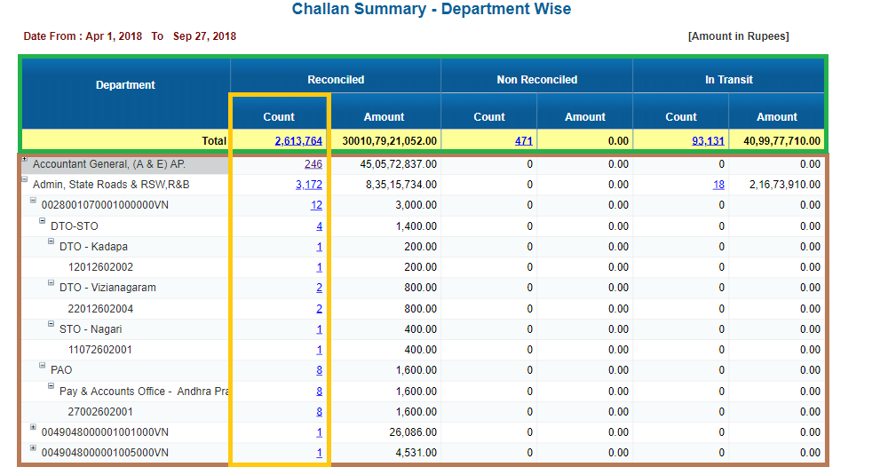

This Report displays **Department, Reconciled, Non Reconciled, In Transit with Count and Amount**

The Rows within the ***Brown*** Box are derived from the Col-Formulas, The Rows with the ***Green*** are derived from the Formulas under Total and The Rows with the ***Orange*** are derived from the Formulas under Count as shown in the above Table.

## Challan Summary-District Wise Report Level Calculations and Formulas used.

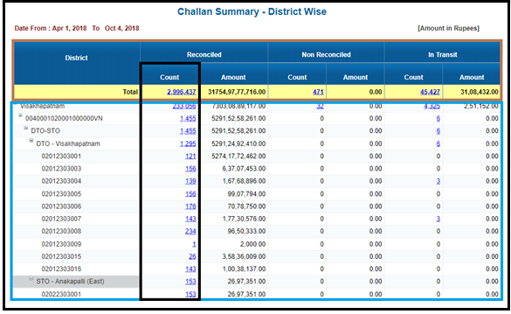

This Report displays Department, Reconciled, Non Reconciled, In Transit with Count and Amount

The Rows within the ***Blue*** Box are derived from the Col-Formulas, The Rows with the ***Brown*** are derived from the Formulas under Total and The Rows with the ***Black*** are derived from the Formulas under Count as shown in the above Table.

## Challan Summary of Reconciled Report Level

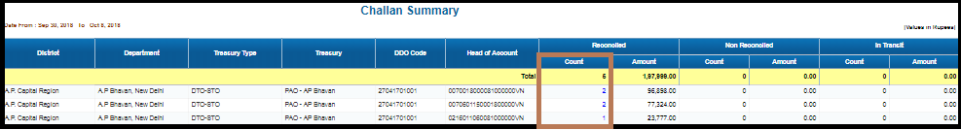

This Report displays Challan Summary, Reconciled with Count and Amount. The Rows with the ***Brown*** are derived from the Formulas under Count as shown in the above Table.

## Challan Summary of Non-Reconciled Report Level

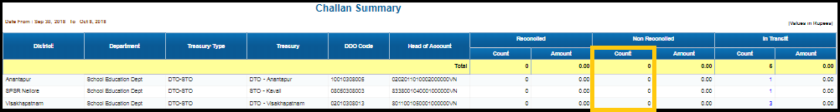

This Report displays Challan Summary, Non-Reconciled with Count and Amount. The Rows with the ***Orange*** are derived from the Formulas under Count as shown in the above Table.

## Challan Summary of In Transit Report Level

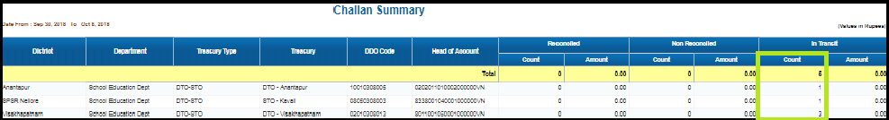

This Report displays Challan Summary, Transit with Count and Amount. The Rows with the ***Green*** are derived from the Formulas under Count as shown in the above Table.

## Challan Details of In Reconciled Report Level

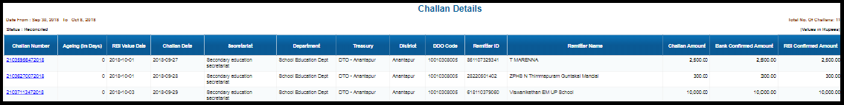

## Challan Details of In Transit Report Level



## Challan Status Display Report Level

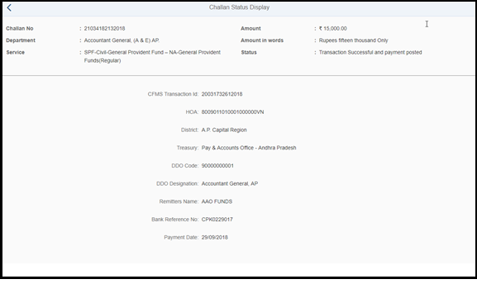

**List of Formulas used in Report Layer.**

|  |  |  |  |  |  |  |
| --- | --- | --- | --- | --- | --- | --- |
| **Column Names** | **Column Description** | **Col-Names Formula Description** | **Sub-Column Names** | **Sub Col-Formula** | **Col-Formula** | **Grand Total** |
| Department | Department With Respect Total Number of challan Summary | =Char(10)+Char(10)+"Department" | NA | NA | =[Department Hierarchy] | NA |
| District | District with respect Total Number of Challan Summary | =Char(10)+Char(10)+"District" | NA | NA | =[District Hierarchy] | NA |
| Reconciled | Reconciled with respect Department and District Wise for Total Challan Summary | =Char(10)+"Reconciled" | Count | =Char(10)+"Count" | =If([Query 3].[Reconciled Challans]>0) Then ("<a href=\"../../opendoc/openDocument.jsp?iDocID=Fi1VM1tKOQ8ADmsAAADn3JYAAFBWly6k&sIDType=CUID&sType=wid&lang=EN_US&sRefresh=N&lsSpsHana%20Variable%20IP_FROM_DATE="+URLEncode(UserResponse([Query 3];"psHana Variable IP_FROM_DATE"))+"&lsSpsHana%20Variable%20IP_TO_DATE="+URLEncode(UserResponse([Query 3];"psHana Variable IP_TO_DATE"))+"&lsSpsHana%20Variable%20IP_HOA="+URLEncode(""+[Department Hierarchy].[ZFI_CHLN_HOA])+"&lsSpsHana%20Variable%20IP_TREASURY_TYPE="+URLEncode(""+[Department Hierarchy].[TREASURY_TYPE])+"&lsSpsHana%20Variable%20IP_DDO="+URLEncode(""+[Department Hierarchy].[ZFI_ORG_DDO].[DDO Code])+"&lsSpsHana%20Variable%20IP_CHLN_STATUS="+URLEncode("Reconciled")+"&lsMpmHana%20Variable%20IP_DISTRICT="+URLEncode(If(Pos(ReportFilterSummary(); "Block 1") = 0 ) Then "" Else ReportFilter([District].[District]))+"&lsMpmHana%20Variable%20IP_DEPARTMENT="+URLEncode(""+[Department Hierarchy].[DEPARTMENT])+"&lsMpmHana%20Variable%20IP_TREASURY="+URLEncode(If(Pos(ReportFilterSummary(); "Block 1") = 0 ) Then "" ElseIf([Department Hierarchy].Depth=4 And Pos(ReportFilterSummary(); "Block 1") > 0) Then [Query 3].[Treasury (for Filter)])+"\" title=\"Click For Reconciled Challan Details\" target=\"_blank\" nav=\"doc\">"+[Query 3].[Reconciled Challans]+"</a>") Else 0 | =If([Query 3].[Reconciled Challans] >0) Then ("<a href=\"../../opendoc/openDocument.jsp?iDocID=Fi1VM1tKOQ8ADmsAAADn3JYAAFBWly6k&sIDType=CUID&sType=wid&lang=EN_US&sRefresh=N&lsSpsHana%20Variable%20IP_FROM_DATE="+URLEncode(UserResponse([Query 3];"psHana Variable IP_FROM_DATE"))+"&lsSpsHana%20Variable%20IP_TO_DATE="+URLEncode(UserResponse([Query 3];"psHana Variable IP_TO_DATE"))+"&lsSpsHana%20Variable%20IP_CHLN_STATUS="+URLEncode("Reconciled")+"&lsMpmHana%20Variable%20IP_DISTRICT="+URLEncode(If(Pos(ReportFilterSummary(); "District") = 0 And Count(UserResponse([Query 3];"District"))=0) Then "" Else ReportFilter([District].[District]))+"&lsMpmHana%20Variable%20IP_DEPARTMENT="+URLEncode(If(Pos(ReportFilterSummary(); "Department Filter") = 0 And Count(UserResponse([Query 3];"Department"))=0) Then "" Else ReportFilter([Department Filter]))+"&lsMpmHana%20Variable%20IP_TREASURY="+URLEncode(If(Pos(ReportFilterSummary(); "Treasury (for Filter)") = 0 ) Then "" Else ReportFilter([Query 3].[Treasury (for Filter)]))+"\" title=\"Click For Reconciled Challan Details\" target=\"_blank\" nav=\"doc\">"+[Query 3].[Reconciled Challans]+"</a>") Else 0 |
| Amount | =Char(10)+"Amount" | =If ([Currency Flag] = 1) Then ([Query 3].[Reconciled Amount])/10000000 Else If([Currency Flag] = 2) Then ([Query 3].[Reconciled Amount])/100000 Else ([Query 3].[Reconciled Amount]) | =Sum(If([Currency Flag] = 1) Then ([Query 3].[Reconciled Amount])/10000000 Else If([Currency Flag] = 2) Then ([Query 3].[Reconciled Amount])/100000 Else ([Query 3].[Reconciled Amount])) Where ([Department Hierarchy].Depth = 1) |
| Non-Reconciled | Non-Reconciled with respect Department and District Wise for Total Challan Summary | =Char(10)+"Non Reconciled" | Count | =Char(10)+"Count" | =If([Query 3].[Non Reconciled Challans]>0) Then ("<a href=\"../../opendoc/openDocument.jsp?iDocID=Fi1VM1tKOQ8ADmsAAADn3JYAAFBWly6k&sIDType=CUID&sType=wid&lang=EN_US&sRefresh=N&lsSpsHana%20Variable%20IP_FROM_DATE="+URLEncode(UserResponse([Query 3];"psHana Variable IP_FROM_DATE"))+"&lsSpsHana%20Variable%20IP_TO_DATE="+URLEncode(UserResponse([Query 3];"psHana Variable IP_TO_DATE"))+"&lsSpsHana%20Variable%20IP_HOA="+URLEncode(""+[Department Hierarchy].[ZFI_CHLN_HOA])+"&lsSpsHana%20Variable%20IP_TREASURY_TYPE="+URLEncode(""+[Department Hierarchy].[TREASURY_TYPE])+"&lsSpsHana%20Variable%20IP_DDO="+URLEncode(""+[Department Hierarchy].[ZFI_ORG_DDO].[DDO Code])+"&lsSpsHana%20Variable%20IP_CHLN_STATUS="+URLEncode("Non Reconciled")+"&lsMpmHana%20Variable%20IP_DISTRICT="+URLEncode(If(Pos(ReportFilterSummary(); "Block 1") = 0 ) Then "" Else ReportFilter([District].[District]))+"&lsMpmHana%20Variable%20IP_DEPARTMENT="+URLEncode(""+[Department Hierarchy].[DEPARTMENT])+"&lsMpmHana%20Variable%20IP_TREASURY="+URLEncode(If(Pos(ReportFilterSummary(); "Block 1") = 0 ) Then "" ElseIf([Department Hierarchy].Depth=4 And Pos(ReportFilterSummary(); "Block 1") > 0) Then [Query 3].[Treasury (for Filter)])+"\" title=\"Click For Non Reconciled Challan Details\" target=\"_blank\" nav=\"doc\">"+[Query 3].[Non Reconciled Challans]+"</a>") Else 0 | =If([Query 3].[Non Reconciled Challans] >0) Then ("<a href=\"../../opendoc/openDocument.jsp?iDocID=Fi1VM1tKOQ8ADmsAAADn3JYAAFBWly6k&sIDType=CUID&sType=wid&lang=EN_US&sRefresh=N&lsSpsHana%20Variable%20IP_FROM_DATE="+URLEncode(UserResponse([Query 3];"psHana Variable IP_FROM_DATE"))+"&lsSpsHana%20Variable%20IP_TO_DATE="+URLEncode(UserResponse([Query 3];"psHana Variable IP_TO_DATE"))+"&lsSpsHana%20Variable%20IP_CHLN_STATUS="+URLEncode("Non Reconciled")+"&lsMpmHana%20Variable%20IP_DISTRICT="+URLEncode(If(Pos(ReportFilterSummary(); "District") = 0 And Count(UserResponse([Query 3];"District"))=0) Then "" Else ReportFilter([District].[District]))+"&lsMpmHana%20Variable%20IP_DEPARTMENT="+URLEncode(If(Pos(ReportFilterSummary(); "Department Filter") = 0 And Count(UserResponse([Query 3];"Department"))=0) Then "" Else ReportFilter([Department Filter]))+"&lsMpmHana%20Variable%20IP_TREASURY="+URLEncode(If(Pos(ReportFilterSummary(); "Treasury (for Filter)") = 0 ) Then "" Else ReportFilter([Query 3].[Treasury (for Filter)]))+"\" title=\"Click For Non Reconciled Challan Details\" target=\"_blank\" nav=\"doc\">"+[Query 3].[Non Reconciled Challans]+"</a>") Else 0 |
| Amount | =Char(10)+"Amount" | =If ([Currency Flag] = 1) Then ([Query 3].[Non Reconciled Amount])/10000000 Else If([Currency Flag] = 2) Then ([Query 3].[Non Reconciled Amount])/100000 Else ([Query 3].[Non Reconciled Amount]) | =Sum(If ([Currency Flag] = 1) Then([Query 3].[Non Reconciled Amount])/10000000 Else If ([Currency Flag] = 2) Then ([Query 3].[Non Reconciled Amount])/100000 Else ([Query 3].[Non Reconciled Amount])) Where ([Department Hierarchy].Depth = 1) |
| In Transit | In Transit with respect Department and District Wise for Total Challan Summary | =Char(10)+"In Transit" | Count | =Char(10)+"Count" | =If([Query 3].[In Transit Challans]>0) Then ("<a href=\"../../opendoc/openDocument.jsp?iDocID=Fi1VM1tKOQ8ADmsAAADn3JYAAFBWly6k&sIDType=CUID&sType=wid&lang=EN_US&sRefresh=N&lsSpsHana%20Variable%20IP_FROM_DATE="+URLEncode(UserResponse([Query 3];"psHana Variable IP_FROM_DATE"))+"&lsSpsHana%20Variable%20IP_TO_DATE="+URLEncode(UserResponse([Query 3];"psHana Variable IP_TO_DATE"))+"&lsSpsHana%20Variable%20IP_HOA="+URLEncode(""+[Department Hierarchy].[ZFI_CHLN_HOA])+"&lsSpsHana%20Variable%20IP_TREASURY_TYPE="+URLEncode(""+[Department Hierarchy].[TREASURY_TYPE])+"&lsSpsHana%20Variable%20IP_DDO="+URLEncode(""+[Department Hierarchy].[ZFI_ORG_DDO].[DDO Code])+"&lsSpsHana%20Variable%20IP_CHLN_STATUS="+URLEncode("In Transit")+"&lsMpmHana%20Variable%20IP_DISTRICT="+URLEncode(If(Pos(ReportFilterSummary(); "Block 1") = 0 ) Then "" Else ReportFilter([District].[District]))+"&lsMpmHana%20Variable%20IP_DEPARTMENT="+URLEncode(""+[Department Hierarchy].[DEPARTMENT])+"&lsMpmHana%20Variable%20IP_TREASURY="+URLEncode(If(Pos(ReportFilterSummary(); "Block 1") = 0 ) Then "" ElseIf([Department Hierarchy].Depth=4 And Pos(ReportFilterSummary(); "Block 1") > 0) Then [Query 3].[Treasury (for Filter)])+"&lsMpmHana%20Variable%20IP_AGEING_BUCKET="+URLEncode(ReportFilter([Query 3].[Ageing Bucket]))+"\" title=\"Click For In Transit Challan Details\" target=\"_blank\" nav=\"doc\">"+[Query 3].[In Transit Challans]+"</a>") Else 0 | =If([Query 3].[In Transit Challans] >0) Then ("<a href=\"../../opendoc/openDocument.jsp?iDocID=Fi1VM1tKOQ8ADmsAAADn3JYAAFBWly6k&sIDType=CUID&sType=wid&lang=EN_US&sRefresh=N&lsSpsHana%20Variable%20IP_FROM_DATE="+URLEncode(UserResponse([Query 3];"psHana Variable IP_FROM_DATE"))+"&lsSpsHana%20Variable%20IP_TO_DATE="+URLEncode(UserResponse([Query 3];"psHana Variable IP_TO_DATE"))+"&lsSpsHana%20Variable%20IP_CHLN_STATUS="+URLEncode("In Transit")+"&lsMpmHana%20Variable%20IP_DISTRICT="+URLEncode(If(Pos(ReportFilterSummary(); "District") = 0 And Count(UserResponse([Query 3];"District"))=0) Then "" Else ReportFilter([District].[District]))+"&lsMpmHana%20Variable%20IP_DEPARTMENT="+URLEncode(If(Pos(ReportFilterSummary(); "Department Filter") = 0 And Count(UserResponse([Query 3];"Department"))=0) Then "" Else ReportFilter([Department Filter]))+"&lsMpmHana%20Variable%20IP_TREASURY="+URLEncode(If(Pos(ReportFilterSummary(); "Treasury (for Filter)") = 0 ) Then "" Else ReportFilter([Query 3].[Treasury (for Filter)]))+"&lsMpmHana%20Variable%20IP_AGEING_BUCKET="+URLEncode(ReportFilter([Query 3].[Ageing Bucket])) |
| Amount | =Char(10)+"Amount" | =If ([Currency Flag] = 1) Then ([Query 3].[In Transit Amount])/10000000 Else If([Currency Flag] = 2) Then ([Query 3].[In Transit Amount])/100000 Else ([Query 3].[In Transit Amount]) | =Sum(If ([Currency Flag] = 1) Then ([Query 3].[In Transit Amount])/10000000 Else If([Currency Flag] = 2) Then ([Query 3].[In Transit Amount])/100000 Else ([Query 3].[In Transit Amount])) Where ([Department Hierarchy].Depth = 1 ) |

**Challan Summary Report Level User Prompts & Input Controls used.**

1. There is **Five** User Prompt used in the Challan Summary Report.
2. From Date
3. To Date
4. District(optional)
5. Department(optional)
6. Treasury(optional)
7. There are **Four** Input Controls used in the Challan Summary Dashboard, Department And District Wise Report.
8. Department Filter
9. Treasury Filter
10. District Filter
11. Currency Scale

Aperndix A –

Appendix B –